# Code Smells

1. Data class

found @ src/main/java/org/jabref/model/textparser/Citation.java

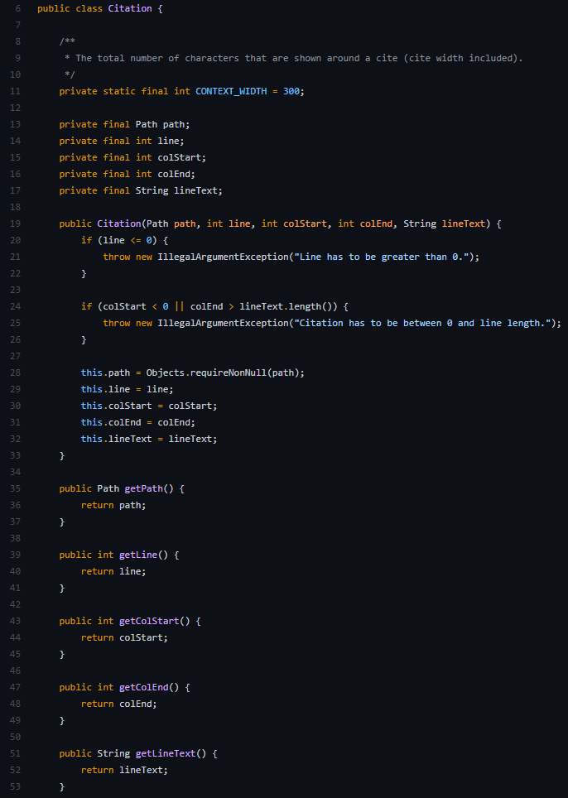

I identified this as a code smell because all instance fields are private and final, has only one constructor and has getters for all fields.

A possible fix could be changing the class to be a *record* (immutable read-only data structure) which are safer to use than a self-made immutable class like the one identified.

1. Dead code/speculative generality

found @ src/main/java/org/jabref/model/entry/field/InternalField.java

I identified this as a code smell because this constructor is never used so it is dead code, but it could also be a code smell of type speculative generality since it could be code prepared to be used in the future.

A possible fix could be the deletion of that snippet of code.

1. Large class

found @ src/main/java/org/jabref/model/entry/BibEntry.java

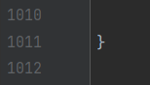

(Chauhan, 2019) uses the threshold 750 lines to determine when a class is considered a large class. Using that knowledge, I identified this as a code smell since the class has 1012 lines.

A possible fix could be the division of the class into two minor classes to divide their work better or create a subclass that handles behavior that can be implemented in a different way or that is used in rare cases, for example, by creating two other classes: one that handles all Keyword related behaviors and the other all Field related behaviors.

# Bibliography

Chauhan, S. S. (2019). *Code Smells Quantification: A Case Study On Large Open Source Research Codebase.*